|  |  |
| --- | --- |
| Store  UXD lab  By Brigida Hurley |  |
|  |  |

|  |
| --- |
| Marketing  Hi this is marketing for portfolio 7 and stores. The stores are for jewellery, shoes, spa and salon, rewards program, games, Ayurveda and Hygiene. Stores with storefronts and structures. Inside these store structures are a convenience store with a gift card for rewards program in convenience store. A slot machine for game. |

# sales

# Advertising products and services to surrounding communities and neighborhoods. Online advertising, web applications and apps. Social media shopping.

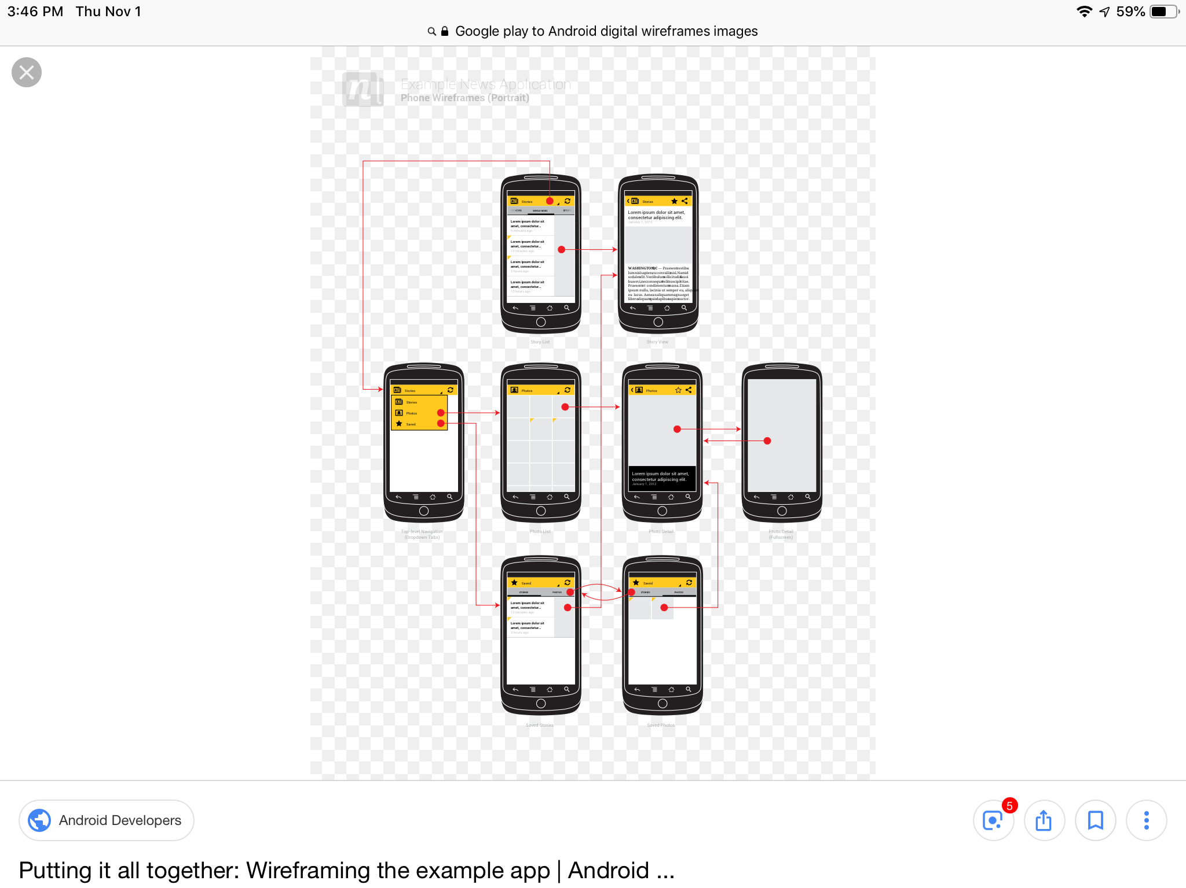

## Marketing, sales and competition would be solved by collaboration and market, sales for sharing things in common.

Web applications, apps, Windows and Android would help sales, marketing and competition, B2B could work and providing options on pay, banking, places and technology trends that are digital.

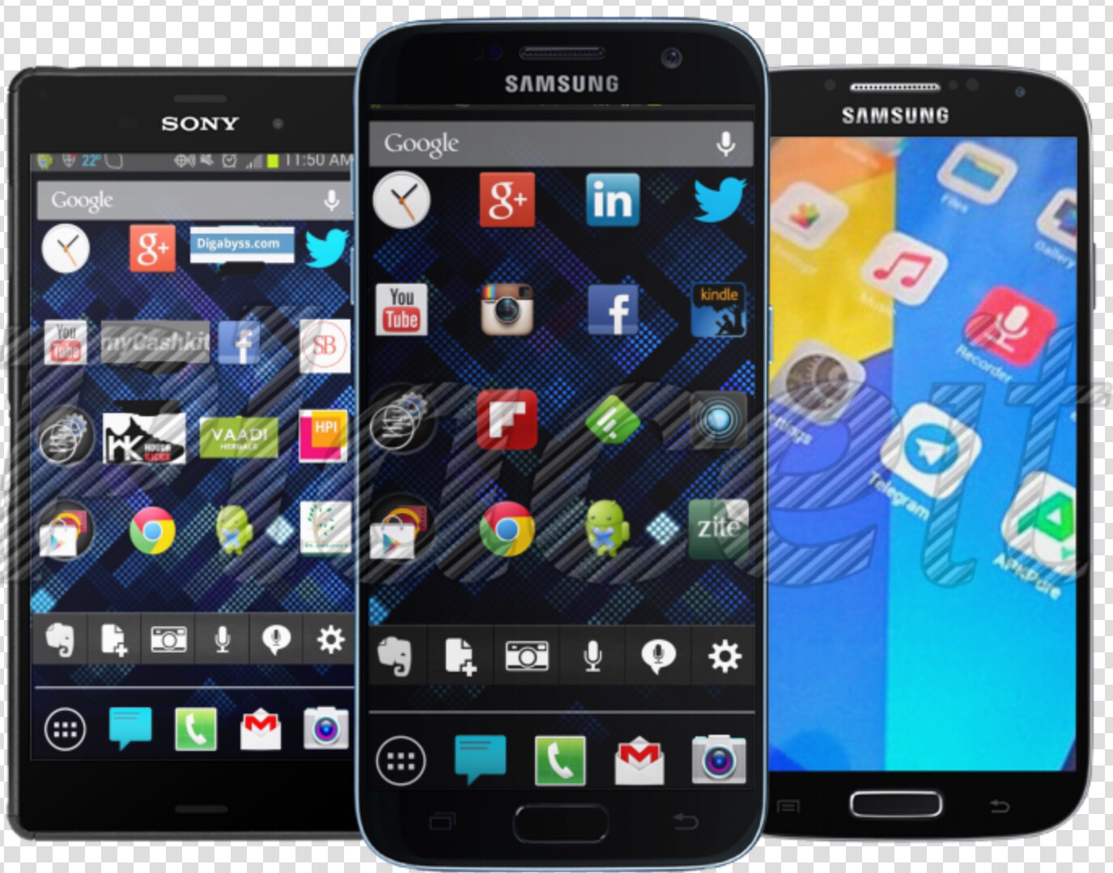Github for portfolio on marketing, sales, and competition. The portfolio is seven with websites and google play.

Android application with business

Windows web applications





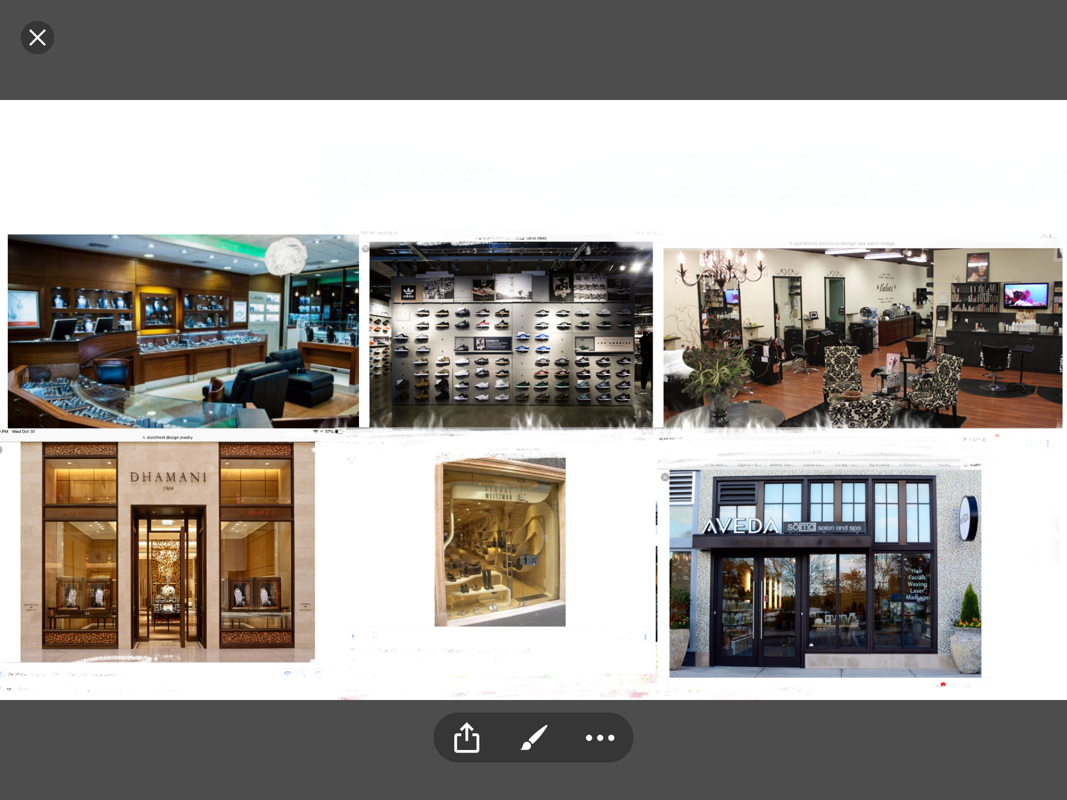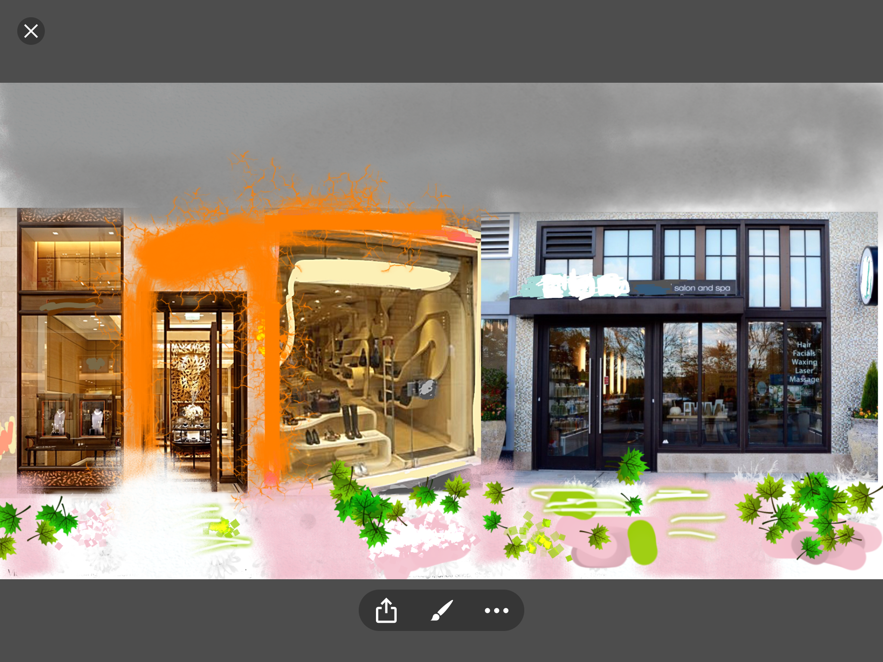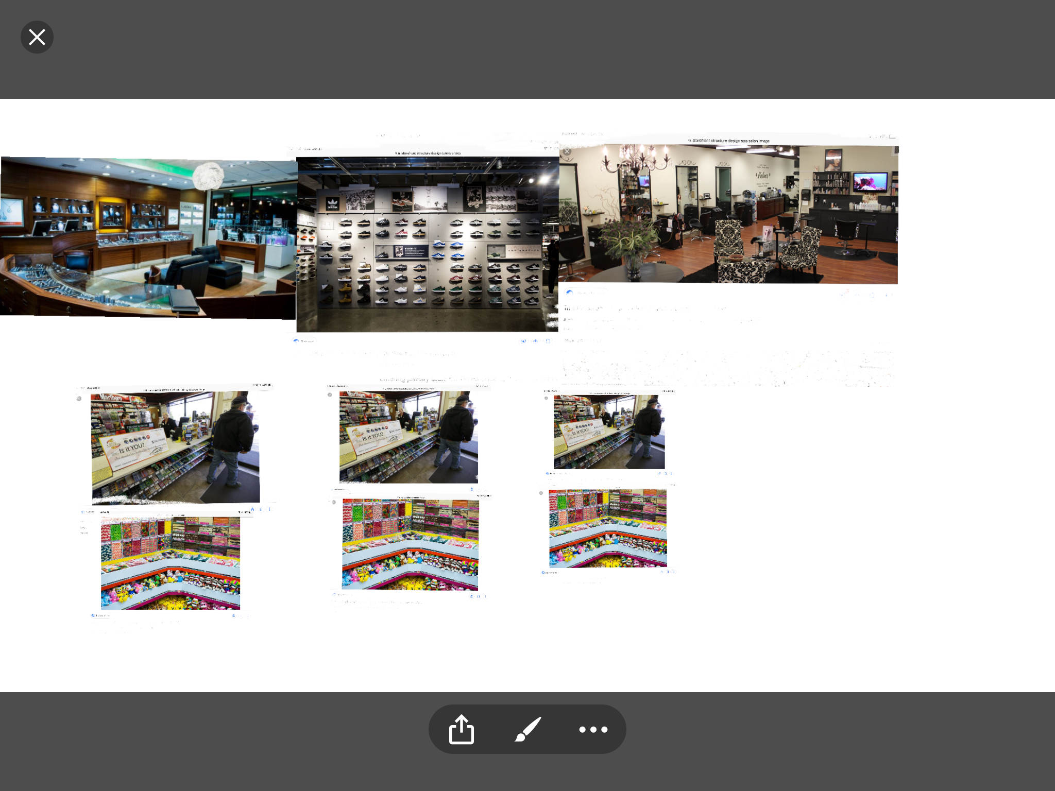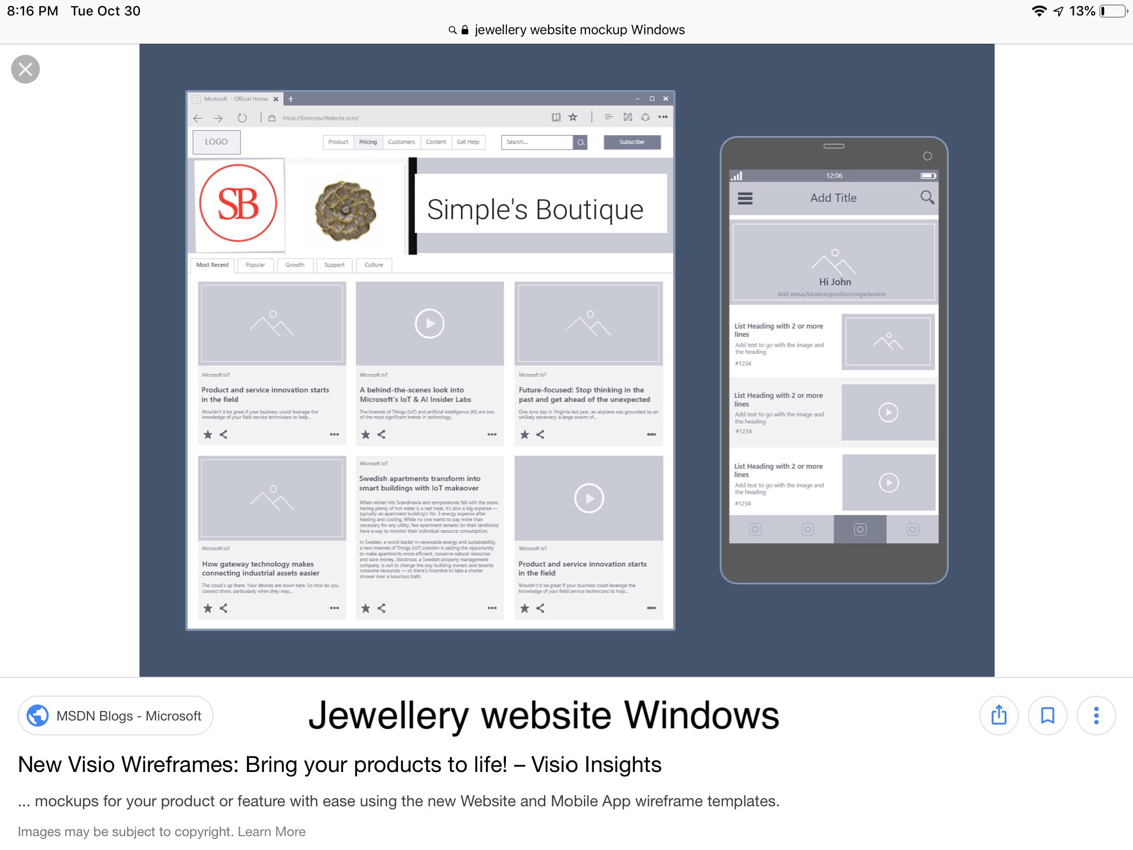

## Wireframes, Mockup, and prototype

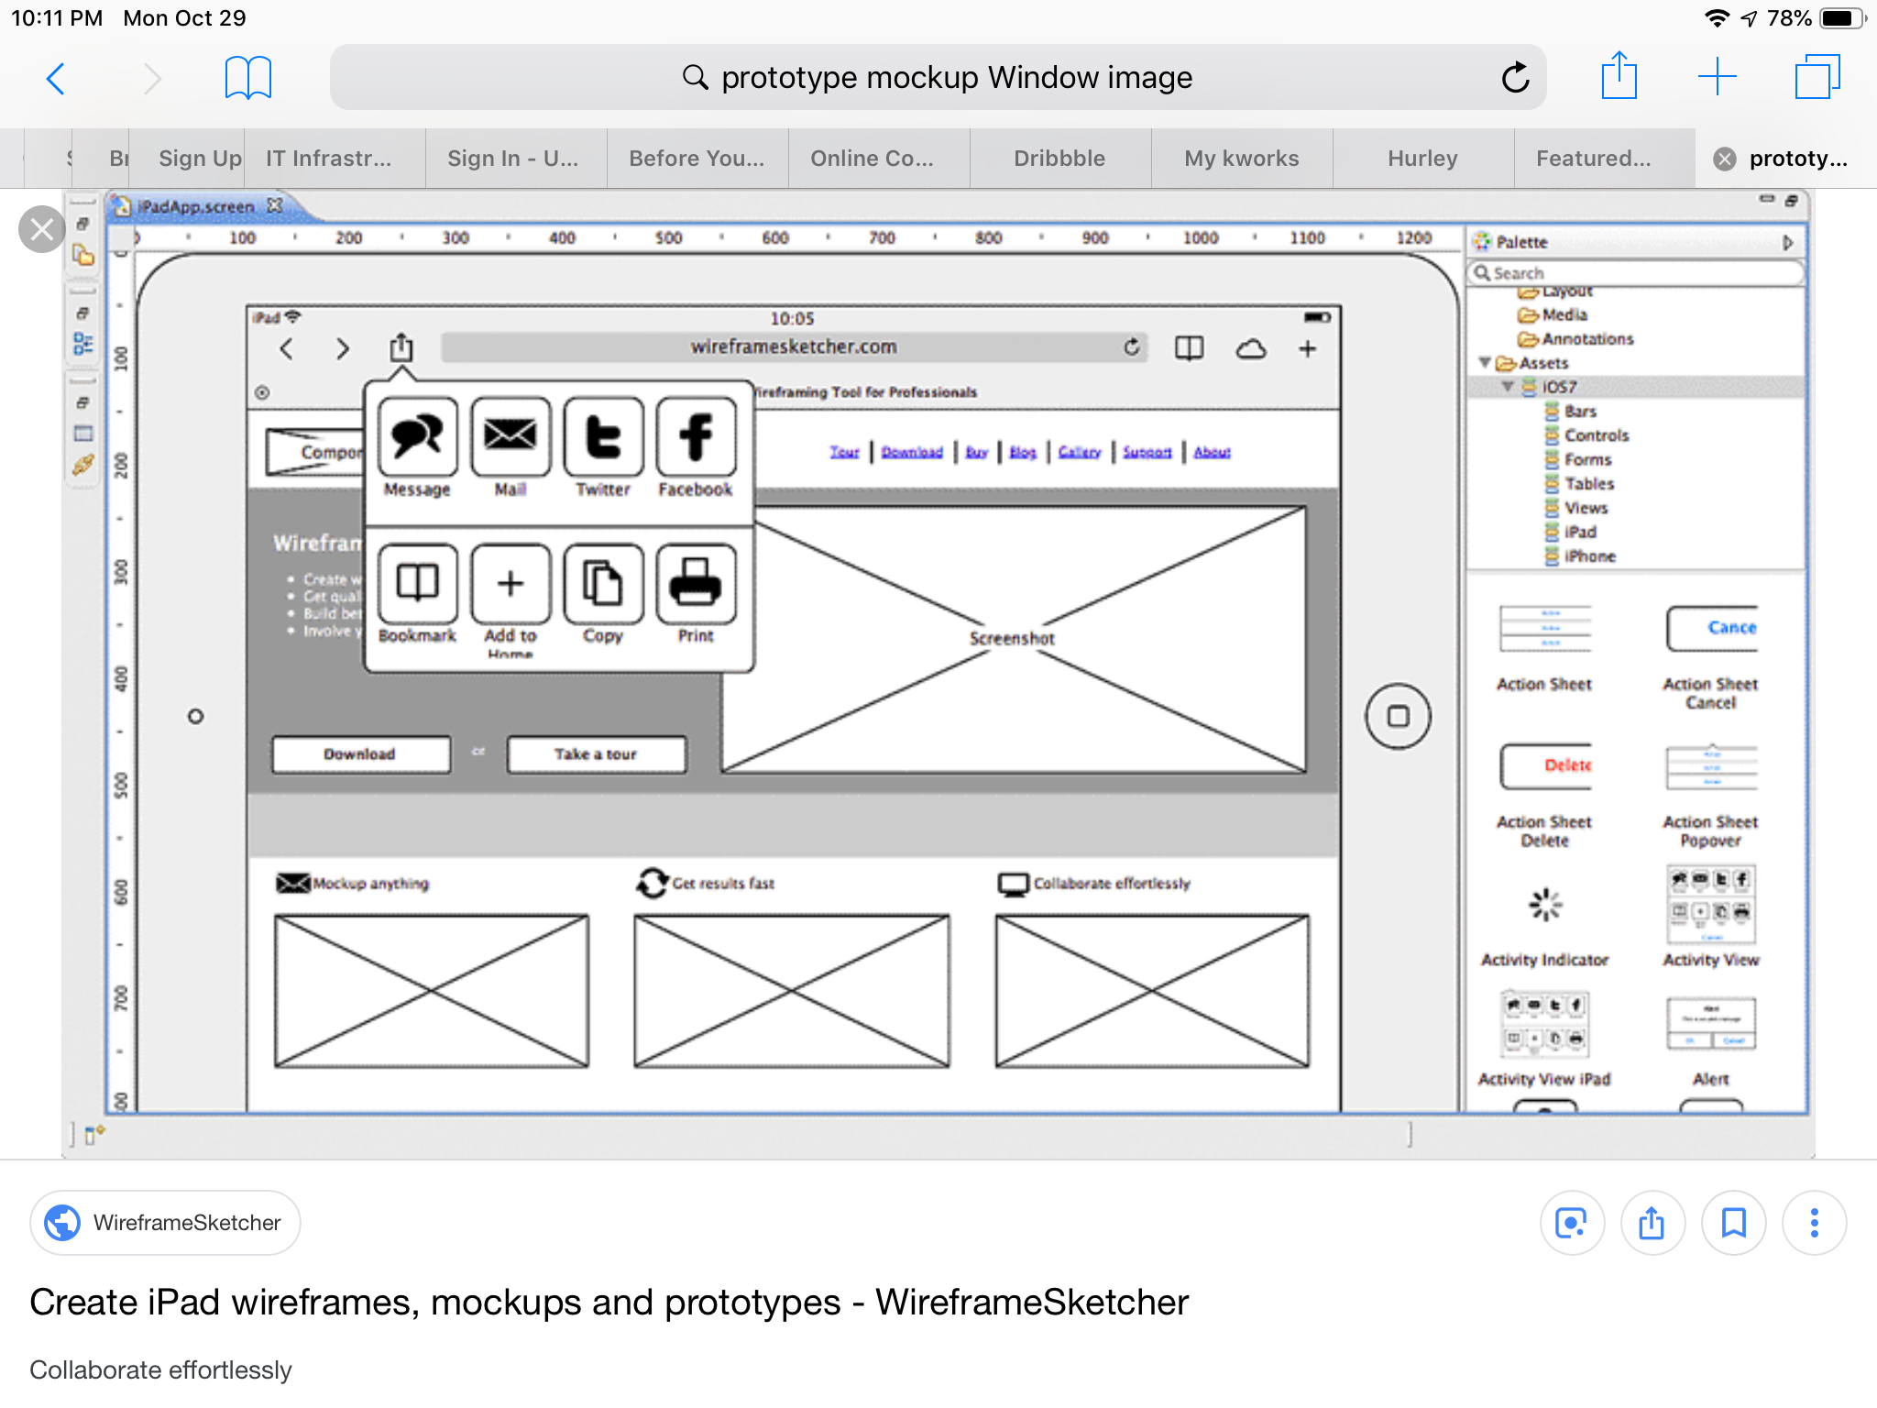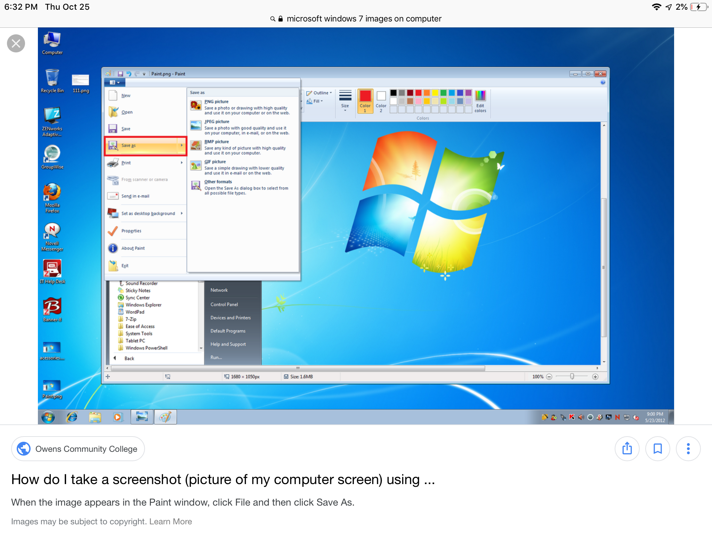The Wireframes will assist to build apps and web applications. Mockup and prototype will give the apps and web applications.

The business are seven but there are 8, however the website link is not working. The website link rehabinit says loading for a long time then Safari shows up. I was contacted by Shubhanshu Garg, and he is from a company UXD lab on LinkedIn. The messenger on LinkedIn was about working as a Business Partner for a IT company. We discussed over Skype, and the company is headquarters in Delhi, India and branches in California and New York. The digital of web applications and apps for Windows and Android.

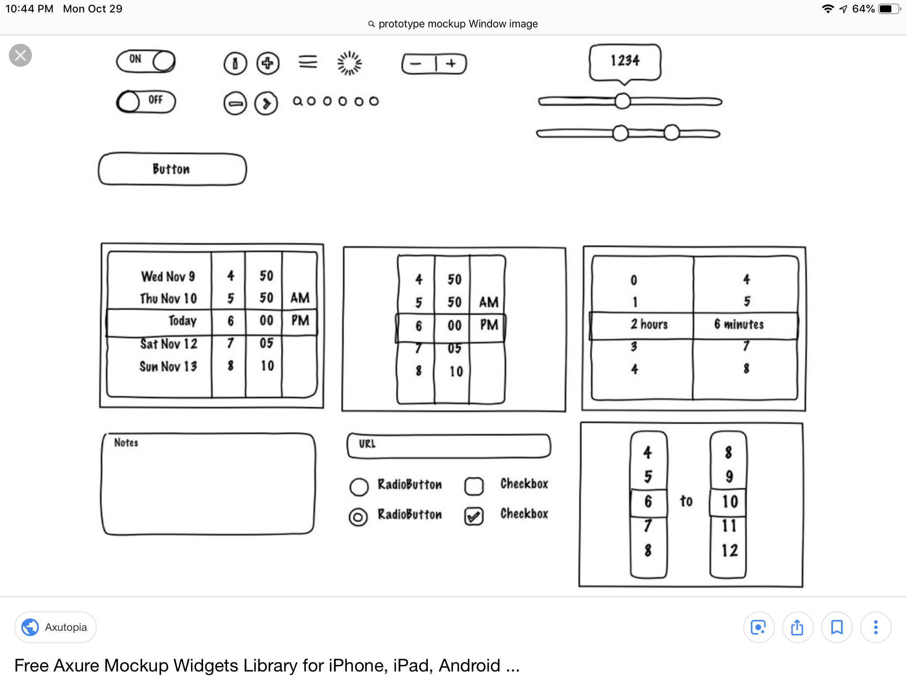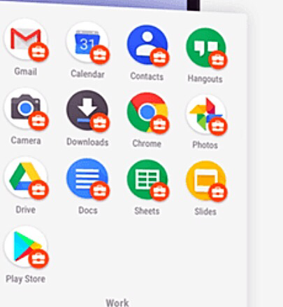



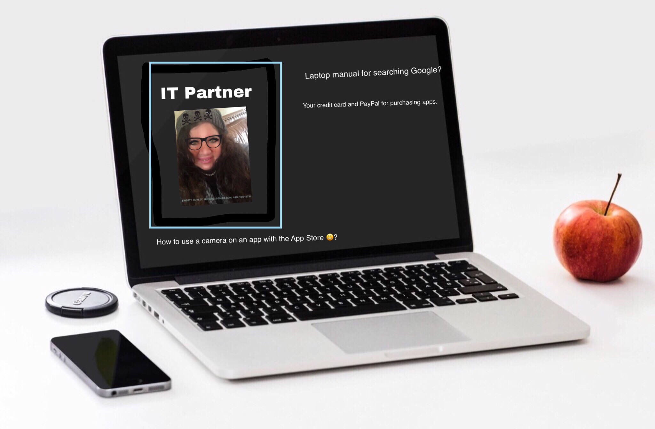Web application, apps, Windows and Android.

Business is growth and plan. Partner is making you better than you were as defined by Wikipedia.

Marketing, Sales and Competition

Business partner and IT company

This is Brigida Brigett Hurley at 480-400-2734, email address [bhhurl1@gmail.com](mailto:bhhurl1@gmail.com)